AP Comparative Government Name __________________________________
Seim

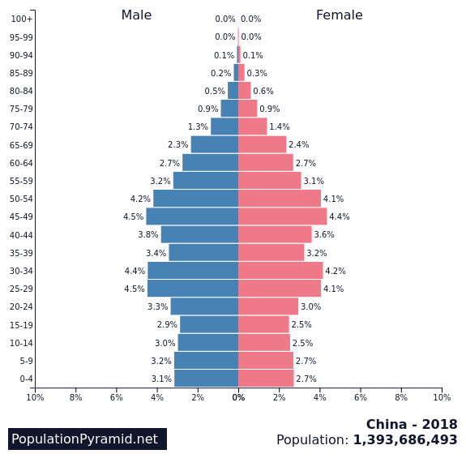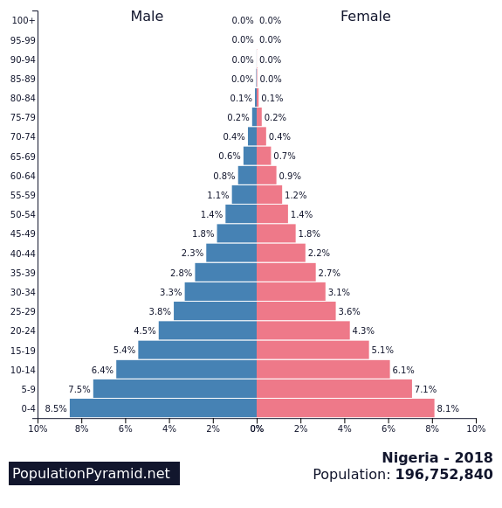

The population pyramids illustrate the age and sex structure of China’s and Nigeria’s populations.
- Using the population pyramids, describe one difference in the age structure of China compared to that of Nigeria.
- Describe one governmental policy that influenced the age structure in China.
- Describe one economic consequence of the age structure of Nigeria.
- Describe one economic consequence of the age structure of China.
- Explain a political consequence of having a disproportionately younger population structure.

